**ASSIGNMENT - 1**

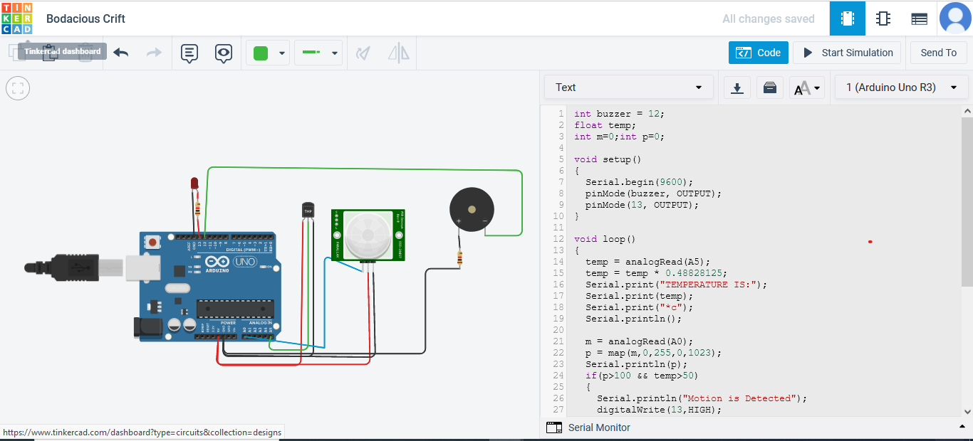

# SUBMITTED BY

# DHILIP DHARSAN